Remote Monitoring of a Compactor Press

Reyner Iván Yparrea Arreola1, Alonso Pérez Monreal1, Josué Sebastián Aviña González1, Manuel Nazario Rocha Martínez2, Francisco Carrasco Hernández2  
1Ingeniería en Mantenimiento Industrial. Universidad Tecnológica de Durango.

2Ingeniería en Mecatrónica. Universidad Tecnológica de Durango.

[reyner.yparrea@utd.edu.mx](mailto:reyner.yparrea@utd.edu.mx), [alonso.perez@utd.edu.mx](mailto:alonso.perez@utd.edu.mx), [sebastian.avina@utd.edu.mx](mailto:sebastian.avina@utd.edu.mx), [francisco.carrasco@utd.edu.mx](mailto:francisco.carrasco@utd.edu.mx)

*Resumen*— En este trabajo se presenta el diseño y desarrollo de un sistema de monitoreo en tiempo real para el ciclo operativo de una prensa de compactación que trabaja con diferentes materiales dentro de una planta de reciclaje de materiales. La base para monitorear su funcionamiento radica en la medición de la corriente entregada por la prensa. Esta variable será interpretada en un panel de control que recibirá datos en tiempo real a través de la plataforma de Amazon Web Services (AWS) y será supervisada por la dirección de la planta. Los indicadores mostrados incluyen tiempo de trabajo en tiempo real, tiempo de inactividad, peso de las pacas terminadas, eficiencia del sistema y material a procesar.

*Palabras Clave* — Eficiencia, reciclado, IIOT, PyME, producción, aumatización.

*Abstract*— In this work, the design and development of a real-time monitoring system for the operational cycle of a compaction press that works with different materials within a material recycling plant are presented. The basis for monitoring its operation lies in the measurement of the current delivered by the press. This variable will be interpreted on a dashboard that will receive real-time data through the Amazon Web Services (AWS) platform and will be monitored by the plant management. The displayed indicators include real-time working time, downtime, weight of the finished bales, system efficiency, and material to be processed.

*Keywords* -- Effiency, recycling, IIOT, PyME, production, automation.

# Introduction

To achieve a future without major environmental complications, it is important to work toward the development of a culture of waste-free production and consumption. Educating, training, and continuing research on the topic are essential to accomplish the goal of zero waste [1].

Sitcam is a company dedicated to the management and handling of industrial waste for subsequent recycling treatment. Including materials such as cardboard, plastic from packaging, PET, and lightweight metal sheets, among others. Currently, the work with this compaction press is entirely manual, and production records are written on a paper sheet by the operator responsible for the task at hand.

Managing a business is not an easy task, and determining the appropriate way to do so is even more challenging. There is no one-size-fits-all formula that describes how to fulfill the managerial role, as success depends on multiple circumstances. Decision-making is one of the various functions performed by managers within an organization [2].

To enhance the efficiency of the compaction machine's operation, the design and development of a remote monitoring system are presented. This system aims to collect different data from the machine and upload it to a private server using the IOT environment, facilitating data management and supporting decision-making by the management team. [3].

It is important to mention that the company in question does not have its systems properly organized, and many of its processes are not recorded or are not recorded correctly, such as hourly production or downtime, among others.

Regarding the production control in the compactor press, the main variable to consider is the weight of the bales that are made, which also do not have a standard in terms of their volume or measurements. For there to be proper feedback on the operators' work, it is of utmost importance to control the weight of the processed material as reliably as possible, in this case, using a scale that is used to record the weight of the finished bales.

Also, the process need to consider the material with which the bales will be made during the compaction. At Sitcam, they process five different materials; therefore, it is crucial to recognize the contributions that this specific manufacturing process could make to the material from which the bales are formed [4].

# Development

The matter of monitoring bale production by this compactor press becomes significant because when it is done in a written manner (if done at all) and without specific formats for this purpose, it becomes difficult to know how much time is spent on this process, how much material is processed, how many bales are produced each day, who made them, and other traceability data.

It's a good option to remove the responsibility of recording everything related to production from the operators and automate the collection of important data such as production time, date, time, final weight of the finished product, among others. Therefore, a monitoring system will be implemented for the compactor press located in Plant 1 of Sitcam.

The implementation of the system is divided into three stages: sensor installation, dashboard interface development and finally, integration.

*2.1. Sensor Installation*

To determine whether the machine is functioning or not, the primary parameter is the presence of current. This indicates whether the pressing process is taking place or not. Therefore, a current sensor and subsequently a weight sensor will be used to determine the weight of the compacted product bale obtained.

The current detection occurs when the button to activate the piston's working cycle, which compresses the material, is pressed. It is considered in this cycle when the piston expands, in this case downwards, and remains in that position for a few seconds to maintain compression before returning to its initial position. This is caused by the power unit of the press, where the sensor is located.

Once the bale production process includes a weight sensor at the output, we will have a completely reliable record that will assist with daily production tracking, efficiency measurement, and goal setting based on the monitored history of operator performance. This will also facilitate the creation of the production standards.

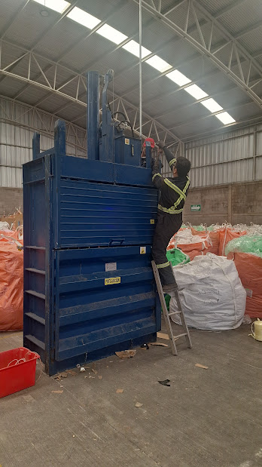

Picture 1. Installation of sensor on the press

*2.2. Interface Development*

Regarding the presentation of the obtained data, a dashboard needs to be prepared to make it easy for the process administrators to observe the generated data and make decisions as required. This interface will utilize the AWS system for remote communication.

In this initial testing phase, the system consists of two tabs. The first one displays graphs of voltage and current measurements, along with a historical record segmented by hours of the press's working time, which is obtained from the current measurement over a specific time period.

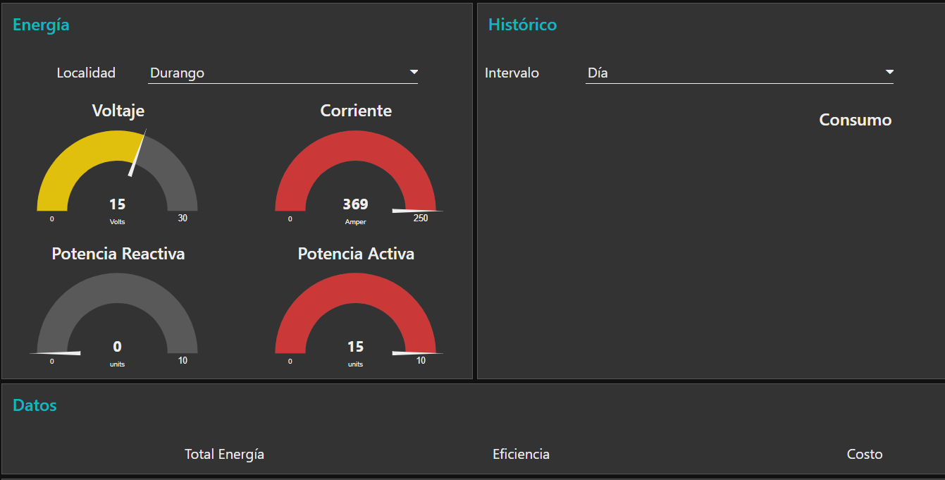

Picture 2. Section 1 of the interface

The second tab displays a graph of weight measurements by the scale, representing the finished bales. This is one of the critical indicators of the process because the quantity of kilograms sold to the customer is what is billed and generates profit. It also helps us review efficiency and assists management with feedback and decision-making in the process.

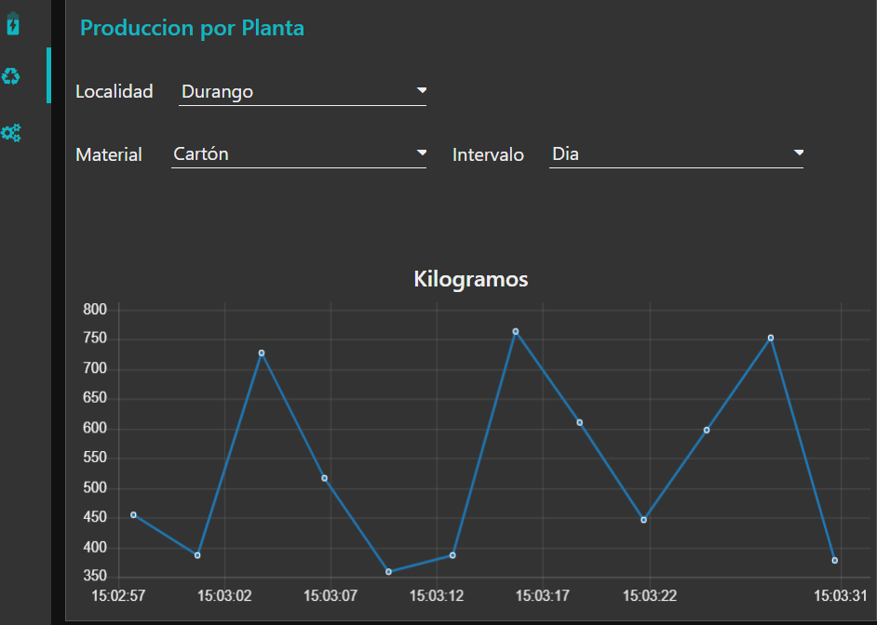

Picture 3. Weight graph over a period of time.

*2.3. Integration*

After connecting the sensor to the press, a signal processing stage is added to monitor in real-time the current coming from the press, which will indicate whether the machine is working or not.

Lastly, the module that is going to process the signal need to be connected to the processor that will be used, and through the Wi-Fi connection to the internet, the communication protocol will be programmed to upload the data to the cloud. The data can then be processed by the AWS system and presented on the dashboard.

# Results and Discussion

*3.1. Results*

This remote monitoring system was completed and installed at Sitcam on June 30, 2023, and began its operation on Monday, July 3, 2023. The platform for tracking production and work or downtime has been well received by the company's management, as it allows measuring production efficiency. And it has reduced the information recording time by up to 80% for the operators.

Sitcam is in the process of creating its quality management system for certification in the ISO 9001:2015 standard by the end of this year. Therefore, this accurate record greatly assists in this effort.

*3.2. Discussion*

The Industrial Internet of Things (IIoT) is an innovative platform that connects a variety of sensors to the Internet, allowing us to take advantage of numerous opportunities to enhance our quality of life through the application of intelligent technology. The concept of the Internet of Things originated from radiofrequency identification networks, developed at the Massachusetts Institute of Technology (MIT) in 1999 by the Automatic Identification Center. The main objective of this system is to effectively capture, process, transmit, and apply information [5].

# Conclusion

The main benefit obtained is that there is now a digital record of daily production, broken down by hour and operator, which did not exist previously. Additionally, it is possible to know with complete accuracy the quantity (kilograms) of processed material, including the number of bales, the weight of each bale, and the type of material they consist of.

This business has three additional presses in the city of Durango and plans to expand its operations to other states in the country. The company intends to implement the system for each of them, as well as acquire different types of machinery for waste processing, and to add in the installation process this system of remote monitoring.

##### Acknowledgement

##### The authors would like to thank the Technological University of Durango and the company Sitcam for their provided support.

##### References

1. Gutberlet, J., Ways out of the waste dilemma: transforming communities in the global south. RCC Perspectives, No. 3, pp 55-68, 2016.J.
2. Clerk Maxwell, A Treatise on Electricity and Magnetism, 3rd ed., vol. 2. Oxford: Clarendon, 1892, pp.68–73.
3. Tualombo-Tituaña, J. J., Figueroa-Soledispa, M. L., & Moreno-Ponce, M. R., Habilidades directivas en el manejo de las finanzas de las pequeñas y medianas empresas. Caso: Sportmancar, Manabí-Ecuador. Revista Científica Fomento de la investigación y publicación científico-técnica multidisciplinaria, Vol. 7, No. 1, pp 775-786, 2022.
4. Urriolagoitia-Sosa, G., Romero-Angeles, B., Hernandez-Gomez, L. H., Torres-Torres, C., & Urriolagoitia-Calderón, G. Crack-compliance method for assessing residual stress due to loading/unloading history: Numerical and experimental analysis. Theoretical and Applied Fracture Mechanics, Vol. 56, No. 3, pp. 188-199, 2011.
5. Malik, P. K., Sharma, R., Singh, R., Gehlot, A., Satapathy, S. C., Alnumay, W. S., Nayak, J., Industrial Internet of Things and its applications in industry 4.0: State of the art. Computer Communications, Vol. 166, pp 125-139, 2021.